Ideation Phase
Brainstorm & Idea Prioritization Template

Date | 31 July 2026
Team ID | Team 1
Project Name | Employee Software Installation Request through Service Catalog
Maximum Marks | 4 Marks

Brainstorm & Idea Prioritization Template:
Brainstorming provides a free and open environment that encourages everyone within a team to participate in the creative thinking process that leads to problem solving. Prioritizing volume over value, out-of-the-box ideas are welcome and built upon, and all participants are encouraged to collaborate, helping each other develop a rich amount of creative solutions.
This template was used to brainstorm approaches for automating the employee software installation request process, and to prioritize the resulting ideas before finalizing the solution direction.
Reference: https://www.mural.co/templates/brainstorm-and-idea-prioritization

Step-1: Team Gathering, Collaboration and Select the Problem Statement
Problem Statement: "How might we enable employees to request licensed software installation in a structured, trackable way — with automatic manager approval and IT fulfillment — instead of relying on informal email requests?"

Step-2: Brainstorm, Idea Listing and Grouping
Ideas generated during the session were clustered into four themes: Request Intake, Approval, Fulfillment, and Escalation.
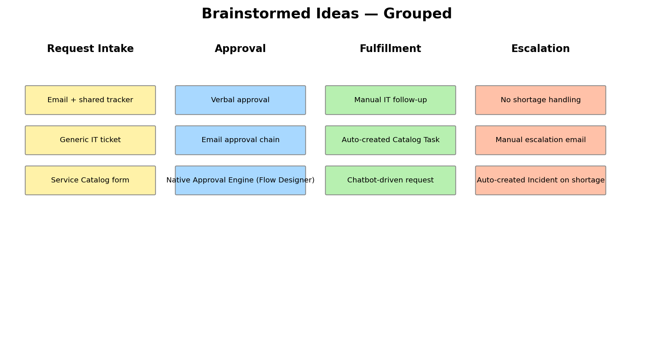

Step-3: Idea Prioritization
Each idea was plotted against Importance and Feasibility to decide which to carry forward. Ideas in the top-right quadrant (high importance, high feasibility) were selected for the solution.
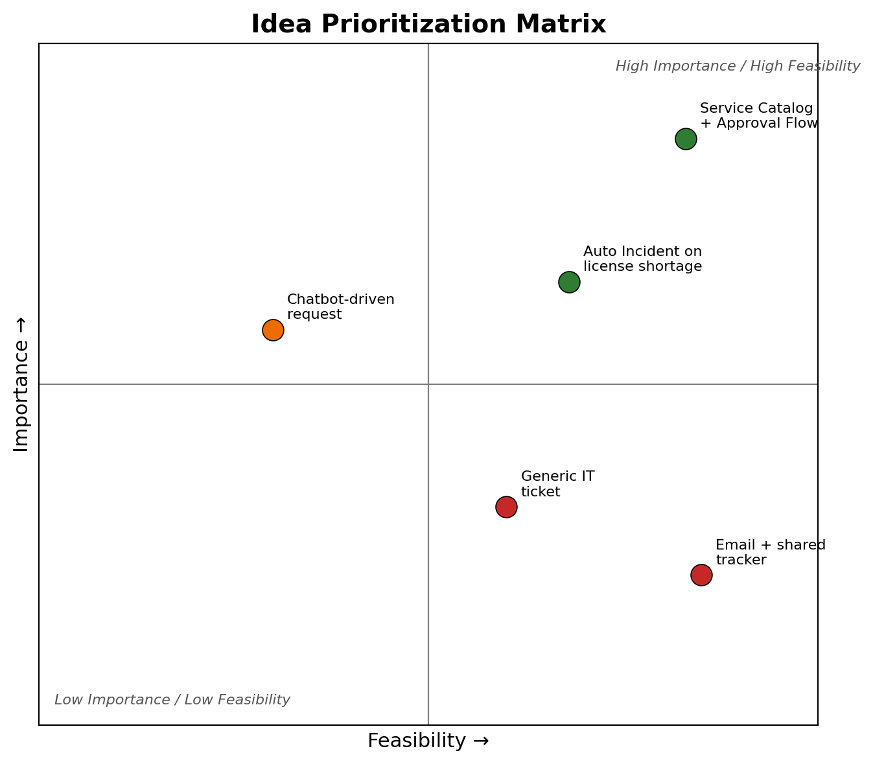
Selected approach: Build a ServiceNow Service Catalog item for software installation requests, with an automated Approval Flow (manager approval), Catalog Task creation on approval, and an automatically raised Incident when a request cannot be fulfilled due to license shortage.

